CARTEEH Project Closeout Checklist
The Project Closeout Checklist documents that all administrative and technical requirements have been completed at the close of a CARTEEH project. The completed checklist must be submitted with the final project report within 60 days after the project completion date.
After receiving the closeout checklist and final research report, CARTEEH leadership will review both and determine whether additional edits are necessary prior to final approval. If edits are required, the document(s) will be returned to the principal investigator (PI) with comments on requested revisions.
Once revisions are completed, the final documents should be returned to CARTEEH for final approval. After notifying the PI of the final approval, CARTEEH administration will upload the research report to the CARTEEH website and various repositories, per the grant’s requirements.

Summary Information
Project Title: <Project Title>
Principal Investigator(s): <enter here>
Co-PIs, Co-investigator(s): <enter here>
Project Start Date: Click or tap to enter a date. Project Completion Date: Click or tap to enter a date.
Final Project Cost: $<enter here>
CARTEEH Funds: $<enter here>
Matching Funds: $<enter here>
Total: $<enter here>
Leveraged Resources (Please Describe): <enter here>

Items to Be Completed
☐ Final technical report (see template)
☐ DOT Form F1700.7 (included in technical report template)
☐ Data uploaded to Data Hub (instructions)
☐ High-resolution (300 dpi) image that represents the project

Project Outputs
A project output is any new or improved process, practice, technology, software, training aid, or other tangible product resulting from this study. List and provide a copy or link to any of the following outputs.
Publications, conference papers, and presentations:
<enter here>
Policy papers:
<enter here>
Websites or other internet sites:
<enter here>
New methodologies, technologies, or techniques:
<enter here>
Inventions, patents, and/or licenses:
<enter here>
Any other projects such as data or databases, physical collections, audio or video products, application software or NetWare, analytical models, educational aids, courses or curricula, instruments, equipment, or research material:
<enter here>

Project Outcomes
Project outcomes are the application of outputs, such as any changes made to the transportation system or its regulatory, legislative, or policy framework. Examples include:
- Increased understanding and awareness of transportation issues.
- Passage of new policies, regulation, rulemaking, or legislation.
- Increases in the body of knowledge.
- Improved processes, technologies, techniques, and skills in addressing transportation issues.
- Enlargement of the pool of trained transportation professionals.
- Adoption of new technologies, techniques, or practices.
<enter here>

Students
List all students who worked on this project, including their degree program and department. If this project contributed to a thesis or dissertation, please include the title of the thesis/dissertation, graduation date, etc.
<enter here>

Certification
I certify that all work on the project titled <Project Title> [select the field, hit F9, and delete this text] is complete, and all required deliverables are complete and submitted.
3/5/2019
Name Date

Please send completed and signed project closeout checklist and final report to m-walker@tti.tamu.edu.

Instructions for Uploading Datasets to the CARTEEH Data Hub
- Register an account at https://carteehdata.org/auth/register.
- Log in with your username and password at https://carteehdata.org/auth/login.
- Go to + New > Dataset at the top right corner of your screen to add a new dataset.
- Briefly describing your dataset by filling in the following minimal information (see the figure below):
Title of the dataset.
Brief description of the dataset.
List of authors (add unregistered authors by clicking on + New Author).
Content license.
Temporal granularity.
Spatial granularity.
Publication/update frequency.
- Click on the Save button to proceed to the next page where you can upload your files
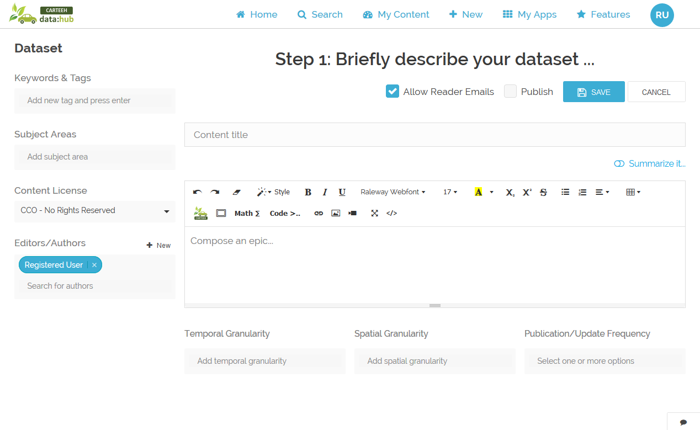
- Click on the Upload Files button and either drag and drop your files or link to existing files on the web (see the figure below).
- Once the file uploads are complete, click on the Publish checkbox, and then click on the Save button to publish your data.
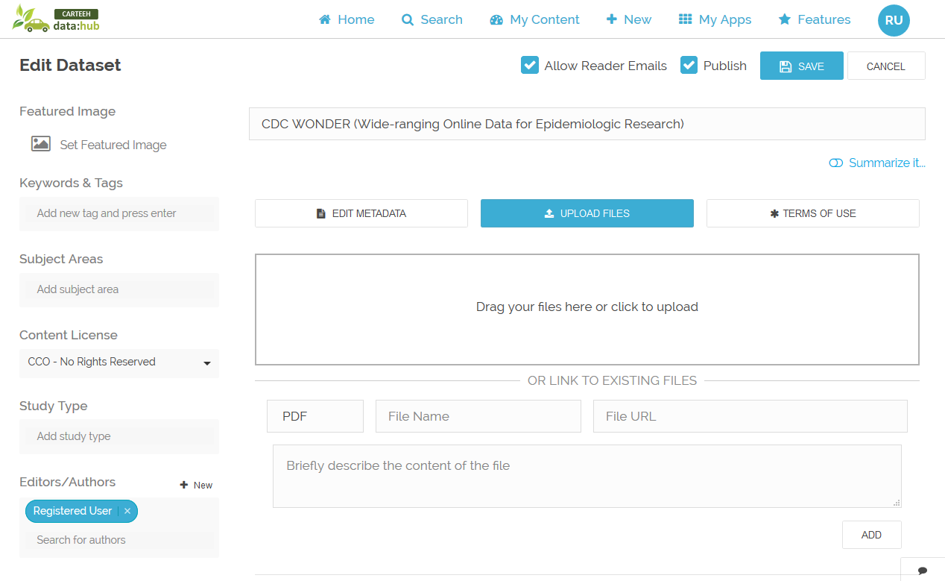

Further Considerations
In addition to meeting the minimum UTC requirements, we encourage you to explore the full range of features at carteehdata.org and think creatively with us about other contributions you may be able to make to the Data Hub. Sharing data via the Data Hub will extend the data’s value beyond the length of your project, and foster an open and collaborative research community around transportation emissions, energy, and health.
We are here to help! Please send your requests and questions to carteehdata@tti.tamu.edu.

Additional Features
Check out additional metadata support and Data Hub features including:
- Native GIS Data Processing.
- Controlled Vocabulary.
- Copyright Permissions and Verification/Notification.
- Custom URLs.
- Access Levels for Various Users.

